Tomato Leaf Disease Detection Using Deep Learning

Sravya Reddy Pilli Sai Vardhan Reddy Harsha Vardhan Reddy

*Computer Science Computer Science Computer Science*

# University of Central Missouri University of Central Missouri University of Central Missouri

***Abstract*—Agriculture stands as the cornerstone of the Indian economy, with tomato cultivation serving as a vital component of its agricultural landscape due to its high yielding rates and significant market presence. However, the susceptibility of tomato plants to various diseases poses a substantial threat to crop yield and quality. Effectively monitoring and identifying these diseases are crucial for mitigating their impact on agricultural productivity. In this paper, we propose a novel approach leveraging deep convolutional neural networks (CNNs) to address the challenge of disease detection in tomato plants, focusing specifically on the prevalent Bacterial Leaf Spot disease.**

**The primary objective of our proposed work is to develop a robust and efficient system capable of accurately predicting the presence of diseases in tomato plant leaves, while also detecting these diseases in their initial stages. To achieve this, we employ the VGG16 architecture, a widely recognized CNN model known for its effectiveness in image processing tasks. The architecture of VGG16 comprises multiple convolutional layers followed by pooling layers, allowing it to extract intricate features from input images and discern patterns relevant to different disease classes. Our methodology involves training the VGG16 model on a**

**dataset consisting of annotated images of healthy tomato leaves as well as those afflicted with Bacterial Leaf Spot disease. Through this training process, the model learns to distinguish between healthy and diseased leaves based on the features extracted from the input images. Subsequently, the trained model is capable of accurately classifying unseen tomato leaf images and identifying the presence of Bacterial Leaf Spot disease.**

**By harnessing the power of deep learning and CNNs, our proposed approach offers a straightforward yet effective solution for disease identification in tomato plants. Moreover, its utilization of the VGG16 architecture ensures compatibility with limited computational resources, making it accessible for deployment in diverse agricultural settings. Overall, our research contributes to advancing the field of agricultural technology by providing a reliable tool for early disease detection and management, thereby enhancing crop health and productivity in the Indian agricultural secto**

***Keywords*—Tomato, Disease Detection, Deep Learning, Convolutional Neural Network, Bacterial Leaf Spot, Agricultural**

**Technology**

I. INTRODUCTION

Agriculture plays a major role in the development of a

country. Farmers face a huge number of issues, for example, insufficiency of water for irrigation, crops withering because of climatic changes and also due to lack of pesticide usage.

Indian economy is highly dependent on agricultural productivity. This is why automation plays an important role in plant leaves disease detection. The plants with diseases are quite natural. If proper care is not taken in these effected leaves, it shows a severe impact on plant growth and productivity. To identify a plant leaf disease in the initial stages itself, we require the automation techniques and process those images to predict the disease attacked or nearer to a disease attack.

In agriculture research of automatic leaf characteristics detection. is essential one in monitoring large fields of crops, and thus automatically detects symptoms of leaf characteristics as soon as they appear on plant leaves. Agricultural research remains a central concern of the developing countries. In India Agriculture contributes around 26 % to the total GDP. It provides livelihood to about 65 % of the labour force and accounts for 8.56% of India’s exports. New technologies, inputs and technique reduce the workload of farmers. Agro Consultant looks for unique ways to increase productivity in efficient manner possible.

India is a country with a majority of the population relying heavily on the agricultural sector. Tomato is the most common vegetable used across India. The three most important antioxidants namely vitamin E, vitamin C and beta-carotene are present in tomatoes. They are also rich in potassium, a very important mineral for good health. Tomato crop cultivation area in India spans around 3,50,000 hectares approximately and the production quantities roughly sum up to 53,00,000 tons, making India the third largest tomato producer in the world. The sensitivity of crops coupled with climatic conditions have made diseases common in the tomato crop during all the stages of its growth. Disease affected plants constitute 10-30% of the total crop loss. Identification of such diseases in the plant is very important in preventing any heavy losses in yield as well as the quantity of the agricultural product. Monitoring the plant diseases manually is a difficult task due to its complex nature and is a time consuming process. Therefore, there is a need to reduce the manual effort put into this task, while making accurate predictions and ensuring that the farmers’ lives are hassle free.

The problem identified is, farmers who are yielding vegetable crop farming are facing several issues in predominant sectors like to determine whether the plant leaves are healthy or not, at a particular point of farming [5]. Thus, this work focusses on, how to detect the plant leaf diseases in an efficient way in early stages itself. In agriculture, detecting leaf diseases is a challenging task which is useful to prevent a serious outbreak. Effortless services must be brought to the farmers which could assist them to identify the affected leaves and the infected plants. This will be beneficial and easy to continue farming services by more sectors of people.

Here in the considered problem, tomato plant leaves are considered for disease detection as tomatoes are more used and purchased vegetable among all the vegetables. The major intention of our innovation is to identify the tomato plant leaf disease in the initial farming stage, including that to predict the disease name of the leaf [6]. Along with the disease name, the proposed work also predicts the precautions to be taken to sustain the hygiene quality in the leaves. Towards addressing the said scenario, the dataset is collected from the kaggle, and preprocessed accordingly. The Neural network owned a special importance in classification and prediction processes. Backpropagation approach is considered and the loss of accuracy is gained by increasing the epochs [7]. In this way, a convolutional neural network system supports in prediction of diseases with better accuracy. Keras library is used to run the code on top of TensorFlow for fast experimentation.

1. MOTIVATION

The agricultural land mass is more than just being a feeding sourcing in today’s world. Indian economy is highly dependent of agricultural productivity. Therefore, in field of agriculture, detection of disease in plants plays an important role. To detect a plant disease in very initial stage, use of automatic disease detection technique is beneficial. The idea focuses on providing the information regarding the pesticide recommendation and the amount of pesticide to be used for an unhealthy crop.

Agricultural productivity is something on which economy highly depends. This is the one of the reasons that disease detection in plants plays an important role in agriculture field, as having disease in plants are quite natural. If proper care is not taken in this area, then it causes serious effects on plants and due to which respective product quality, quantity or productivity is affected.

The tomato crop is an important staple in the Indian market with high commercial value and is produced in large quantities. Diseases are detrimental to the plant’s health which in turn affects its growth. To ensure minimal losses to the cultivated crop, it is crucial to supervise its growth. There are numerous types of tomato diseases that target the crop’s leaf at an alarming rate. The main aim of the proposed work is to find a solution to the problem of tomato leaf disease detection using the simplest approach while making use of minimal computing resources to achieve results comparable to state of the art techniques. Neural network models employ automatic feature extraction to aid in the classification of the input image into respective disease classes.

1. MAIN CONTRIBUTIONS AND OBJECTIVES

The project contribution is split between three members : Sravya Reddy, Harsha Vardhan, Sai Vardhan.

* Sai Vardhan –Development of a Deep Learning Model: Developed a convolutional neural network model using VGG16 architecture to identify diseases in tomato plant leaves.

Utilization of Minimal Resources: Emphasized the model’s efficiency by designing it to operate with minimal computational resources. Dataset Preparation and Management: Managed the dataset including collection, preprocessing, and augmentation to improve model training and accuracy.

* Harsha Vardhan – Image Processing Application: Applied image processing techniques to preprocess and classify images of plant leaves to detect early signs of disease. Model Training and Testing: Involved in rigorous training and validation of the neural network model to ensure reliability and efficiency in real-world applications.
* Sravya Reddy – Specialization in Early Detection Techniques: Specialized in the early detection of plant diseases using machine learning, helping prevent widespread crop damage.

Technical Expertise in Neural Networks: Showed expertise in neural network design and implementation, particularly in adjusting and optimizing the VGG16 model for plant disease detection. Contributions to Data Handling and Analysis: Played a critical role in the analysis and interpretation of image data, ensuring the model’s effectiveness in identifying disease markers.

IV. RELATED WORK

Tomato Plant Disease Detection System using Image Processing [2018] by Santosh Adhikari . The CNN-based classifiers are tested on a subset of the disease dataset, including tomato plant leaf diseases. The dataset consists of 3 leaf diseases of the tomato plant, including grey spot (113 samples), Late Blight (121 samples), Bacterial Canker (111 samples). Adding healthy tomato leaf images, the used dataset contains 520 images in 3 categories. The images of the dataset are resized to fit into 412×412 dimensions which are chosen to be relatively small and close to a fraction of the average size of all images. Then a simplified CNN architecture is proposed and trained with and without the residual learning framework to compare the results. All the diseases which may affect the growth of tomato plant has been analysed. Different diseases have different features and symptoms, by classifying these visual symptoms of diseases data is trained on convolution neural network (CNN) after training model is created which can detect all the diseases.

Tomato Leaf Disease Detection Using Convolutional Neural Networks [2018] by Prajwala Tm. The proposed approach includes the three important stages namely: Data Acquisition, Data pre-processing and Classification. Flow diagram is shown in Fig. 4 and current section includes the brief discussions of the same. The implementation of the proposed methodology has been carried out on the Plant Village dataset. It consists of around 18160 images belonging to 10 different classes of tomato leaf diseases. Keras, has been used for the model implementation. Out of the 18160 images, 4800 images were set aside for testing and 13360 images were used for training. In order to increase the dataset, automatic data augmentation techniques has been used by randomly rotating the images by a small amount of 20 degrees, horizontal flipping, vertical and horizontal shifting of images The optimization was carried out using Adam optimizer with categorical cross entropy as the loss function. Batch size of 20 has been used and the model has been trained for 30 epochs. A highest validation accuracy of 94.8% was obtained over 30 epochs of training, while a high 99.3% of training accuracy was reported. This is an effective measure of the classification made by the deep learning model.

Tomato crop disease classification using pre-trained deep learning algorithm [2018] by AK Rangarajan. Tomato crop disease classification has been performer with the images from PlantVillage dataset using pre-trainer deep learning architecture namely AlexNet and VGG16 net. The classification accuracy using 13,262 images were 97.29% for VGG16 net and 97.49% for AlexNet. The performance of the model has been evaluated by modifying the number of images, setting various minibatch sizes and varying the weight and bias learning rate. The number of images significantly affected the performance of the models. Maximum accuracy is obtained when the number of images is 373. Fine tuning of the minibatch size in AlexNet did not show a clear correlation to the accuracy of classification but the accuracy in VGG16net decreased as the minibatch size is increased. Similarly, by fine-tuning weight and bias learning rate, the accuracy in AlexNet decreased until the learning rate is 30 and then increased sharply. In VGG16 net the accuracy dropped as weight and bias learning rate is increased. In terms of computational load, AlexNet provides a good accuracy with minimum execution time compared to the deep VGG16 net.

PLANT DISEASE DETECTION USING NEURAL NET-WORK. [2019] by K Muthukannan In classification of Diseased plant leaves using Neural Network Algorithms et al. K. Muthukannan detected spot diseases in leaves and that are classified based on the diseased leaf types using various neural network algorithms. The methodology used to classify the diseased plant leaves using Feed Forward Neural Network (FFNN), Learning Vector Quantization (LVQ) and Radial Basis Function Networks (RBF) by processing the set of shape and texture features from the affected leaf image. The simulation results show the effectiveness of the proposed scheme. With the help of this work, a machine learning based system can be formed for the improvement of the crop quality in the Indian Economy.[1]

Automatic Detection of Tomato Leaf Deficiency and its Result of Disease Occurrence through Image Processing [2019] by S. Sivagami, S. Mohanapriya In proposed system, the images of tomato leafs are collected for our implementation work. The images may be normal and healthy, deficiency affected and disease affected. We are going to detect whether the leaf is affected by any deficiency. The result of deficiency leads to disease occurrence in plants and it affect the yield. Therefore, efficient identification of deficiency will reduces disease occurrence in plants.

The first paper is about the “Tomato Plant Disease Detection System using Image Processing”, written by Santosh Adhikari. The experimental results showed that the proposed CNN-based model can reach a good recognition performance, and obtained an average accuracy of 96.3%.

In the Second paper, i.e “Tomato Leaf Disease detection Using Convolutional Neural Networks”, The database used for evaluation is a subset of Plant Village, a repository that contains 54,306 images of 14 crops infested with 26 diseases. The subset includes around 18160 images of tomato leaf diseases.

In Third paper “Tomato crop disease classification using pre-trained deep learning algorithm”, The classification accuracy using 13,262 images were 97.29% for VGG16 net and 97.49% for AlexNet. In Fourth paper “PLANT DISEASE DETECTION USING NEURAL NETWORK”, The methodology used to classify the diseased plant leaves using Feed Forward Neural Network (FFNN), Learning Vector Quantization (LVQ) and Radial Basis Function Networks (RBF) by processing the set of shape and texture features from the affected leaf image.

V. PROPOSED FRAMEWORK

# A. Design Methodology

The proposed methodology used dataset from kaggle. This process is used to predict whether a leaf is diseased or not. In this we will consider some of the important attributes from leaf like size, color, shape, texture etc. and based on that we will predict is, whether a tomato plant leaves are diseased or not. From the dataset and real time application, we considered some major attributes of leaf like colour, shape, size, texture, etc. Using these, the proposed system is modelled to study the disease type and predict how much part of the tomato leaf is diseased. Also the leaf is diseased or not is also experimented. Plant leaf disease detection models can also be performed using IOT technology [12].

In the proposed system, it is modelled such a way that farmer initially uploads the image into testing folder to apply testing of tomato plant leaf. Within no time, the image is pre-processed to remove unwanted content and passed to the proposed system. Then the next step is detection and localization of the image through implementation of backpropagation method. The classifier taken is VGG16 which is used to classify the features of the input samples. Vgg 16 is used with cnn architecture to classify. For this keras platform is used. Based on the components of leaf-like colour, texture the diseases like bacterial leaf spots are identified. Figure 1 shows the illustration process of the proposed method.

# B. Proposed Architecture

In this the tomato leaf is taken as input and disease considered to detect is Bacterial Leaf Spot. Pre-processing of input samples (1000) is taken to eliminate the raw content in the images. The next step is algorithm section to compare the features of the input image with the existing images in the training set. Then the neural network classsifier will classify, whether the input leaf image is diseased or not. If it is diseased, the proposed model will display the name of the disease, and precautions need to be taken to overcome that disease.

The client means the person who utilizes this methodology. The client may be a farmer or any person who has interest in automate in cropping. This section is about taking input samples as a dataset. It contains both healthy leaves and bacterial leaf spot leaves. Plant Village dataset is collected from kaggle. It is the process thatstarts from the initial stage. It helps us to collect the important key features from the input images for accurate prediction.

# C. Pre-processing

Before passing input images to the algorithm or model, the samples have to undergo an important step. That is image Pre-processing. In this phase, the raw content of the data samples were filtered. Here the word filtered means, resizing the images, reshaping the images, Due to colour and space enhancement, we can improve the visual analysis and quality for further disease identification process.

# D. Train Test Split

Spitting the data into two halves is the most essential phase for training a prediction model in data science. The completed data is taken into two parts. One is training set and another one validation set. Most commonly, the percentages of divided sets will be like training as 80% and testing at 20%. In training and testing, training is to teach the model, testing is to predict the success rate of the model. Sample images of training and testing sets are as follows.

The images which have been trained. Initially, 80% of the complete dataset is considered as a training set. Neural network applies learning from training dataset. In this recording is done for the first time. Later, it learns by doing a lot of iterations until the predicted output matches the actual output. The normal word indicates that, the leaf is doesn’t affected with any type of disease. It is resulted, when the about constraint is satisfied. This means that there is no disease to the plant leaf. The abnormal word indicates that, the leaf is not in a healthy condition. Leaf is suffering from the presence of disease. It is resulted, when the leaf is in an abnormal condition. If the model detects the leaf is unhealthy, it prints the name of the disease presence of the leaf. To specify precautions, when the leaf is in unhealthy condition, safety measure are specified by the model that are to be taken to overcome the obtained disease. To conclude, the results obtained from normal and abnormal are again passed to the client (farmers). In this way, the proposed architecture is used

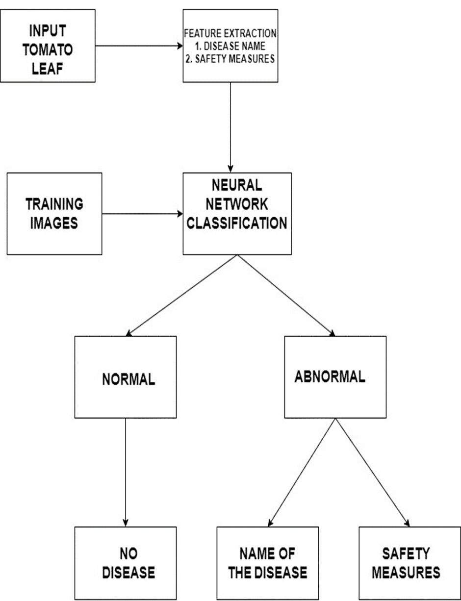

Fig. 1. Architecture Diagram

for further process to identify the healthy and unhealthy leaves.

# E. CNN Algorithm Layers

CNN Layers: In general, every neural network works like brain functionalities. Each network is considered as a group of neurons, every layer is completely in contact with another layer. But convolutional neural network has different architectures, each and every layer in CNN is designed as three dimensional architecture. They are depth, height and length. Mainly there are three layers in Convolutional Neural Networks [13]. They are the Input layer, the Hidden layer, Output layer. In the first layer, we provide inputs for the model. Then, the result of the initial layer is forwarded to the next layer. This layer performs a major operation called matrix multiplication. In this layer, the result of the current layer is multiplied with result of the preceding layer using bias and weights. There are several hidden layers, but these layers are selected based on the models. Hidden layers like convolution layer, pooling layer, softmax layer etc. The outcomes of hidden layers are the inputs for the output layer. Here in this, there is a sigmoid function that processed the result of each class into a probability score. There are many hidden layers, which are helpful to prove a result for our models [14]. In those, one is a Convolution layer. It is first and most the important layer that extracts the features from the image. It is the layer where CNN learns. No of parameters the Conv layer would be ((width of the filter*height of the filter+1)*no of filters). Another one is the Pooling layer, it is used to reduce the no of parameters, when the image is too large. Pooling layers are designed in two types. One is Max Pooling, another one is Min Pooling. Another one is Fully Connected Layer, where we flatten our matrix into the vector and passed to this layer. The parameters in this layer would be ((current layer n*previous layer n)+1)[15]. In this paper the image classification is done through VGG16 (Visual Geometry Group). To make use of this model, we have to import Keras library. It is trained model using the imagenet dataset and having International Journal of Advanced Science and Technology Vol. 29, No. 4s, (2020), pp. 3145-3154 ‘ 3151 ISSN: 2005-4238 IJAST Copyright 2020 SERSC 1000’s of output categories. It works on a strategy called transfer learning. Transfer learning learns knowledge by solving one problem and applies that to the related problems to solve. The major step in VGG16 is, it will eliminate the last layer and appends it with the output category class. VGG16 designed like, the image size should be 224X224. As the name indicates it performs a total of 16 layers of operation for classification. Finally, in the place of the last layer our output layer is appended.

Convolutional neural networks have been one of the most influential innovations in the field of computer vision. They have performed a lot better than traditional computer vision and have produced state-of-the-art results. These neural networks have proven to be successful in many different reallife case studies and applications, like: • Image classification, object detection, segmentation, face recognition; • Self driving cars that leverage CNN based vision systems; • Classification of crystal structure using a convolutional neural network; Input Layer: The image shows you that you feed an image as an input to the network, which goes through multiple convolutions, subsampling, a fully connected layer and finally outputs something. • So no learnable parameters here. Thus number of parameters = 0.

Convolution Layer: Convolution is the first layer to extract features from an input image. Convolution preserves the relationship between pixels by learning image features using small squares of input data. This is where CNN learns, so certainly we’ll have weight matrices. To calculate the learnable parameters here, all we have to do is just multiply the by the shape of width m, height n and account for all such filters k. Number of parameters in a CONV layer would be : ((m *

n)+1)*k), added 1 because of the bias term for each filter. The same expression can be written as follows: ((shape of width of the filter*shape of height of the filter+1)*number of filters).

Pooling Layer: Pooling layers section would reduce the number of parameters when the images are too large. Here we uses max pooling for our leaf images during CNN process. Max Pooling: Max pooling takes the largest element from the rectified feature map. Taking the largest element could also take the average pooling. Sum of all elements in the feature map call as sum pooling. • So no learnable parameters here.

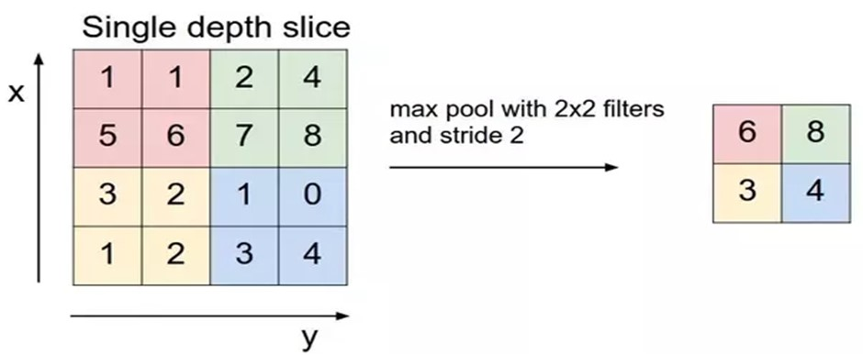

Fig. 2. Max Pooling

Thus, number of parameters = 0.

Fully Connected Layer: The layer we call as FC layer, we flattened our matrix into vector and feed it into a fully connected layer like a neural network. In this, take the product of the number of neurons in the current layer and the number of neurons on the previous layer. Thus number of parameters here : ((current layer n*previous layer n)+1). Neural Network calculation for 1 leaf image in our dataset: 1. The first input layer has no parameters. 2. The second CONV1(filter shape =5*5, stride=1) layer has how many parameters? Let’s do the math according to the formula: it is ((shape of width of filter*shape of height filter+1)*number of filters) = (5*5*3 + 1) * 8 = 608 3. The third POOL1 layer has no parameters. 4. The fourth CONV2(filter shape =5*5, stride=1) layer has how many parameters? Let’s do the math according to the formula: it is ((shape of width of filter*shape of height filter+1)*number of filters) = (5*5*8 + 1) * 16 = 3216 5. The fifth POOL2 layer has no parameters. 6. The Sixth FC3 layer has ((current layer n*previous layer n)+1) parameters = 400*120 + 120 = 48120, since the bias should have 120 parameters, not 1 7.

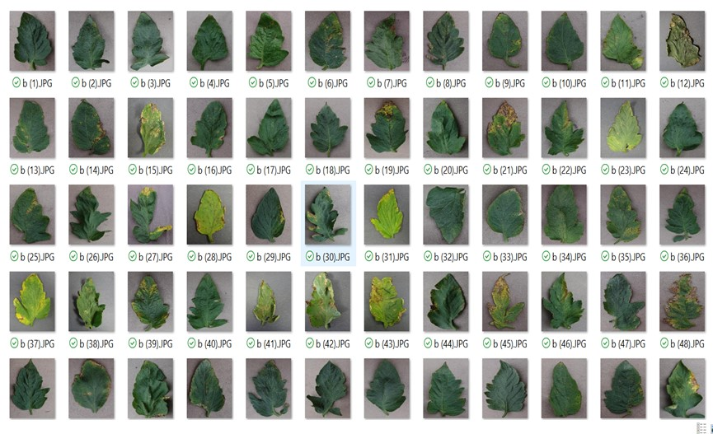

Fig. 3. Dataset

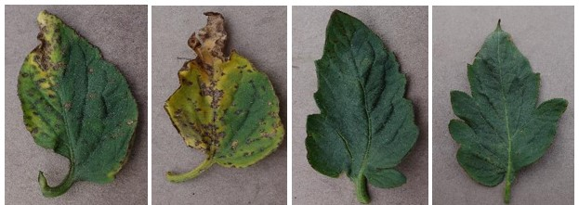

Fig. 4. Two bacterial leaf spot diseased images and two heal

thy images

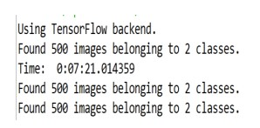

Fig. 5. Number of samples considered

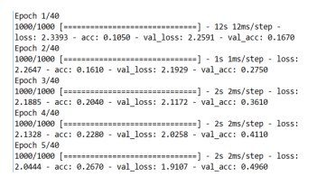

The Seventh FC4 layer has ((current layer n*previous layer n)+1) parameters = 120*84 + 84 (not 1) = 10164 8. The Eighth Softmax layer has ((current layer n*previous layer n)+1) parameters = 841 should be 84*10 + 10 = 850

Algorithm: Back propagation. Neural network learning for classification or numeric prediction, using the back propagation algorithm.

Input: D, a data set consisting of the training tuples and their associated target values; L, the learning rate; Network, a multilayer feed-forward network. Output: A trained neural network.

# F. Method

(1)Initialize all weights and biases in network;

(2) while terminating condition is not satisfied {

(3) for each training tuple X in D {

(4) // Propagate the inputs forward:

(5) for each input layer unit j {

(6) Oj = Ij; // output of an input unit is its actual input value

(7) for each hidden or output layer unit j {

(8) Ij =Pi wijOi + θj; //compute the net input of unit j with respect to the previous layer, i

(9) Oj =11+e−Ij; } // compute the output of each unit j

(10) // Backpropagate the errors:

(11) for each unit j in the output layer

(12) Errj = Oj(1 − Oj)(Tj − Oj); // compute the error

(13) for each unit j in the hidden layers, from the last to the first hidden layer

(14) Errj = Oj(1 − Oj)Pk Errkwjk; // compute the error with respect to the next higher layer, k

(15) for each weight wij in network {

(16) 1wij = (l)ErrjOi; // weight increment

(17) wij = wij + 1wij; } // weight update

(18) for each bias θjin network {

(19) 1θj = (l)Errj ; // bias increment

(20) θj = θj + 1θj; } // bias update

(21) } }

VI. DATA DESCRIPTION

The dataset utilized for this study is sourced from Kaggle, a well-known platform for machine learning and data science competitions. This particular dataset comprises a collection of images that include both diseased and non-diseased tomato plant leaves. The primary focus of the disease identification is on Bacterial Leaf Spot, a common affliction in tomato plants that can significantly impact agricultural productivity.

This dataset is presented in its raw form, ensuring that the original characteristics of the images are preserved for accurate analysis and processing. The images provide a varied representation of the leaf conditions, with different stages of disease manifestation clearly visible. This variety is crucial for training a robust machine learning model, especially a convolutional neural network (CNN), which relies heavily on diverse data inputs to learn discriminative features effectively.

In the context of agricultural research, the availability of such a detailed and specific dataset is invaluable. It allows researchers and technologists to develop, test, and refine models that can accurately detect and classify leaf diseases at early stages. Early detection is key to managing plant diseases effectively, preventing the spread and minimizing damage to crops.

For anyone interested in developing or testing their own disease detection algorithms, this dataset provides a realistic challenge due to its diversity and the complexity of the symptoms associated with Bacterial Leaf Spot. By leveraging such data, researchers can contribute to advancements in agricultural technology, ultimately aiding farmers in maintaining healthy crops and improving yield. The dataset’s accessibility through Kaggle also encourages a collaborative approach to solving this significant agricultural problem, inviting contributions from around the globe.

RESULTS/ EXPERIMENTATION & COMPARISON/ANALYSIS

For this model learning, total of 1000 images were used. Here learning process means, the model is trained based on input parameters and classifies the input images into different classes as shown in figure 5. The input images are of both diseased and non-diseased tomato leaves. We processed the classification technique with CNN based algorithm, using tomato plant healthy leaves and bacterial spot diseased leaves. For disease classification, the transfer learning approach is used, which is the application of a pre-trained model. VGG16 is used in this study. The batch size set to 50 and epochs are about 7. 96% of accuracy is obtained over 7 epochs and 50 batch size. We can obtain an efficient classification using deep learning neural networks. The data about input images are shown in fig 1 There are total of 500 images in the training set and 500 images in the validation set. The epochs, we considered here are 7. The following images indicate the model training process, accuracy, loss, time period details. The accuracy of disease classification is estimated with an equal number of images for both healthy and disease named classes which are shown in figure 6. By reducing the number of input images in each class, the accuracy may vary.

The above two figures 6 and 7 represents the number of epochs used in this work. Accuracy and loss are also presented. Data visualization makes more sense to the deep learning neural network model. Most of the prediction base models may visualize their data using graphs, based on parameters

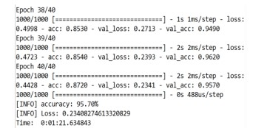

Fig. 7. No of Epochs

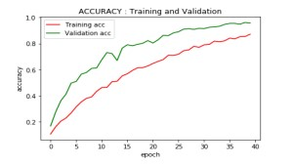

Fig. 8. Accuracy

like accuracy and loss for the complete data. The following graphs in figure 8 and 9 denotes the graphical representation for plant leaf disease detection.

Figure 8 and figure 9 presents the training accuracy, validation accuracy, training loss, validation loss. In the accuracy measure graph shown in figure 8, epochs are shown on x-axis and accuracy is taken on y-axis. Similarly, in loss measure graph shown in figure 9, epochs are taken on x-axis and loss is taken on y-axis. Training data is presented with red color, validation data is presented with green color. Now let

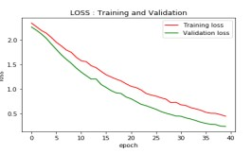

Fig. 9. Loss

us discuss about testing phase. In this model, the combination of both tomato healthy and tomato bacterial spot leaves were considered. When the model is executed, the considered test samples are viewed on the screen. By analyzing those test samples, features like name of the disease and precautions were printed on the resultant image. In this work, the model is inspected with several test cases. The above tomato leaf image is also resulted as an uninfected leaf. So, the image is titled with a healthy one.

Towards identifying the diseased leaves in tomato plant application, we developed a model, to automate the process of plant leaf disease detection. Tomato is the most common crops which is produced in large yields. This proposed model used deep learning based convolutional neural networks. There is an achievement in terms of accuracy of about 95performance is altered by modifying the count of input and epoch values. The problems faced during the farming can be reduced using this model. From this model, we can gain the features like name of the disease and the precautions need to be taken to overcome that disease. In future study, we will work on multiple species of plants and on multiple diseases of plants. And also, it will be more convenient when we designed an application or userfriendly GUI to handle this model because the farmers will not have much more technical resources

REFERENCES

1. Gurleen kaur Sandhu, “Plant Disease Detection Techniques: A Review”, International Conference on Automation, Computational and Technology Management (ICACTM), (2019).
2. Akbar Hidayatuloh, M. Nursalman, Eki Nugraha, “Identification of Tomato Plant Diseases By Leaf Image Using Squeezenet Model”, International Conference on Information Technology Systems and Innovation (ICITDI), (2018)
3. Ishrat Zahan Mukti, Dipayan Biswas, “Transfer Learning Based Plant Diseases Detection Using ResNet50”, 4th International Conference on Electrical Information and Communication Technology (EICT), (2019).
4. So Yahata, Tetsu Onishi, Kanta Yamaguchi, Seiichi Ozawa et, “A Hybrid

Machine Learning Approach To Automatic Plant Phenotyping For

Smart Agriculture”, International Joint Conference on Neural Networks (IJCNN), (2017)

1. Ramesh Medar, Vijay S. Rajpurohit, Shweta, “Crop Yield Prediction Using Machine Learning Techniques”, IEEE 5th International Conference for Convergence in Technology (I2CT), (2019)
2. S. Santhana Hari, M. Sivakumar, P. Renuga, S. Karthikeyan, S. Surya, “Detection Of Plant Diseases By Leaf Image Using Convolutional Neural Neyworks”, International Conference on Vision Towards Emerging Trends in Communication and Networking, (2019)
3. Haiguang Wang, Guanlin Li, Zhanhong Ma, Xiaolong Li, “Application Of Neural Networks To Image recognition Of Plant Disaeses”, International Conference on Systems and Informatics (ICASAI2012), (2012).
4. Prajwala TM, Alla Pranathi, Kandiraju et “Tomato Leaf Disease Detection Using Convolutional Neural Networks”, Eleventh International Conference on Contemporary Computing (IC3), (2018).
5. Suma V, R among Shetty, Rishab F Tated, Sunil Rohan, Triveni S Pujar, “CNN based Leaf Disease Identification And Remedy Recommendation System”, 3rd International Conference on Electronics, Communication and Aerospace Technology (ICECA), (2019).
6. Azeddine Elhassouny. Florentin Smarandache, ”Smart Mobile Application To Recognize Tomato Leaf Disease Using Convolutional Neural Networks”, International Conference of Computer Science and Renewable Energies (ICCSRE), (2019).
7. R. Meena Prakash, G.P. Saraswathy, G. Ramalakshmi, K.H. Mangaleswari, T. Kaviya, ”Detection Of Leaf Diseases And Classification Using Digital Image Processing”, International Conference on Innovations in Informations, embedded and Communication Systems (ICIIECS),(2017).
8. Monirul Islam Pavel, Syed Mohammad Kamruzzaman, Sadam Sakib Hasan, Saifur Rahman Sabuj, “An IoT Based Plant Health Monitoring System Implementing Image Processing”, 4th International Conference on Computer and Communication Syatems (ICCCS), (2019).
9. Akshay kumar, Vani M, “Image Based tomato Leaf Disease Detection”, 10th International Conference on Computing, Communication and Networking Technologies (ICCCNT), (2019).
10. Peng Jiang, Yuehan Chen, Bin Liu, Dongjian He, Chunquan Liang, “Real Tme Detection Of Apple Leaf Diseases Using Deep Learning Approach Based On Improved Convolutional Neural Networks”, Advanced Optical Imaging for Extreme Environments, Volume: 7, (2019).
11. Endang Suryawati, Rika Sustika, R. Sandra Yuwana, Agus Subekti, Hilman F. Pardede, “Deep Structured Convolutional Neural Network For Tomato Diseases Detection”, International Conference on Advanced Computer Science and Information Systems (ICACSIS), (2018).
12. Jihen Amara, Bassem Bouaziz, Alsayed Algergawy et al., ”A Deep Learning-based Approach for Banana Leaf Diseases Classification”, BTW (Workshops), pp. 79-88, 2017
13. S. D. Khirade and A. B. Patil, ”Plant Disease Detection Using Image Processing”, 2015 International Conference on Computing Communication Control and Automation, pp. 768-771, Feb. 2015.
14. ]Sharada P. Mohanty, David P. Hughes and Marcel Salathe, ”Using deep´ learning for image-based plant disease detection”, Frontiers in plant science, vol. 7, pp. 1419, 2016.
15. Usama Mokhtar et al., ”SVM-based detection of tomato leaves diseases” in Intelligent Systems 2014, Springer, pp. 641-652, 2015.
16. Alex Krizhevsky, Ilya Sutskever and Geoffrey E. Hinton, ”Imagenet classification with deep convolutional neural networks”, Advances in neural information processing systems, pp. 1097-1105, 2012.

.